Sample output:

1. First login:

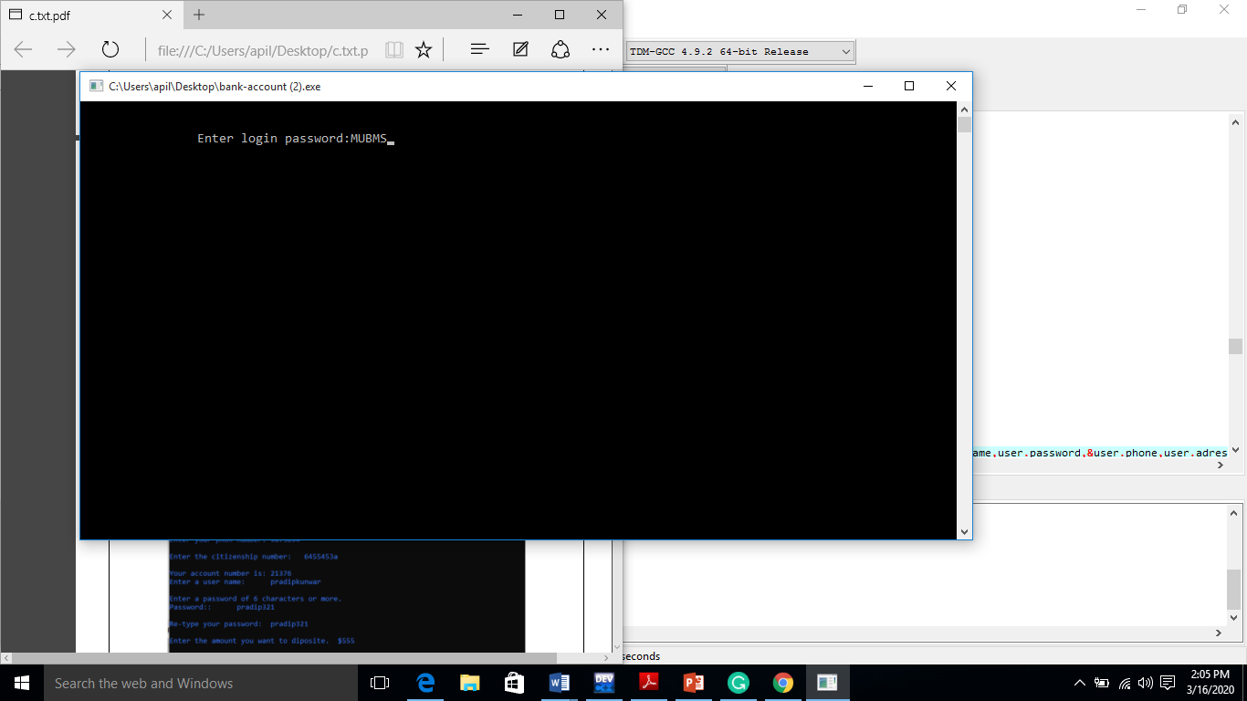

Program provide this login password. When enter password: MUBMS will be login in main menu.

1. Main menu

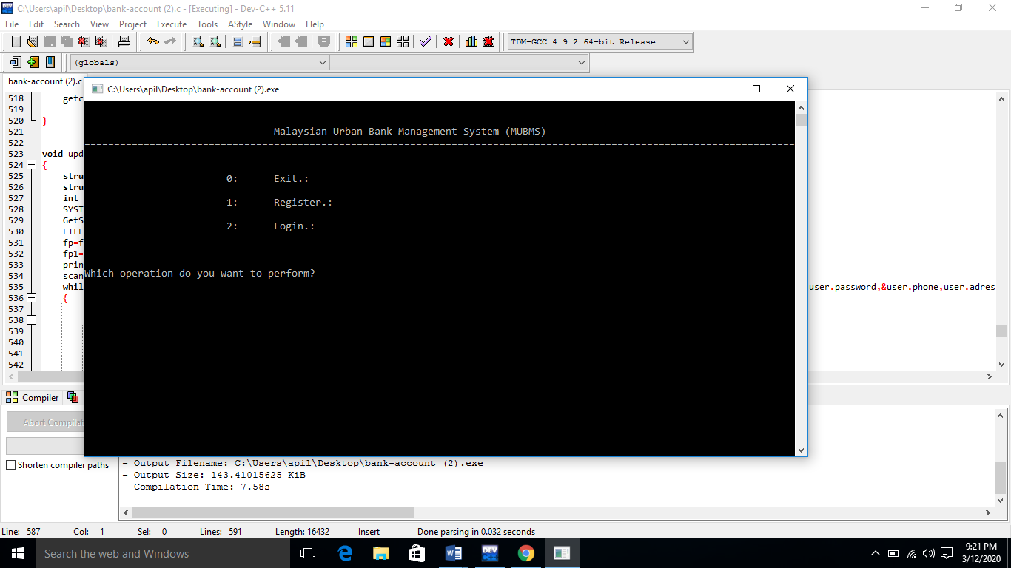

When login first login then displays 0. Exit, 1. Register, 2. Login. Choice one of them.

1. Register

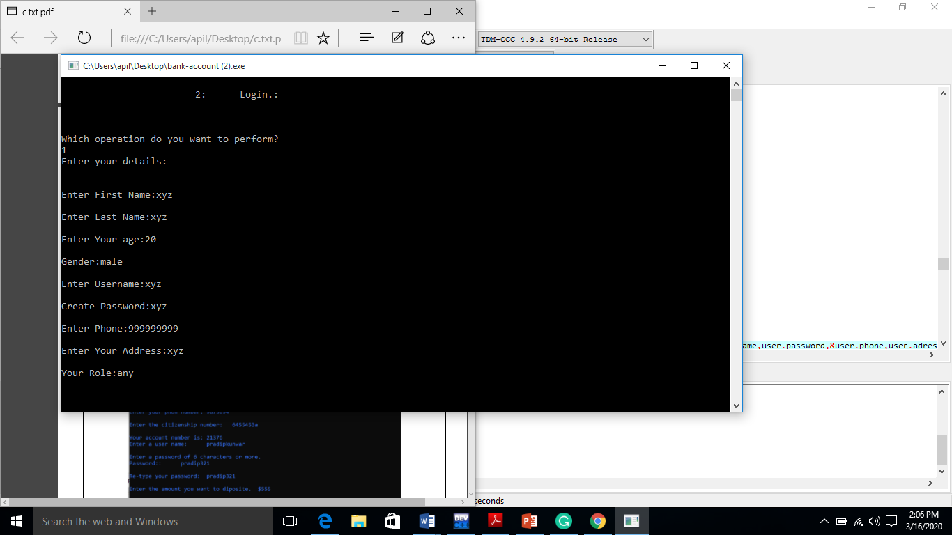

When user want to register then show option like enter first name, last name, age, gender, username, password, phone number, address and role then it registers. When register data will save in ‘details.txt’ file.

1. Login

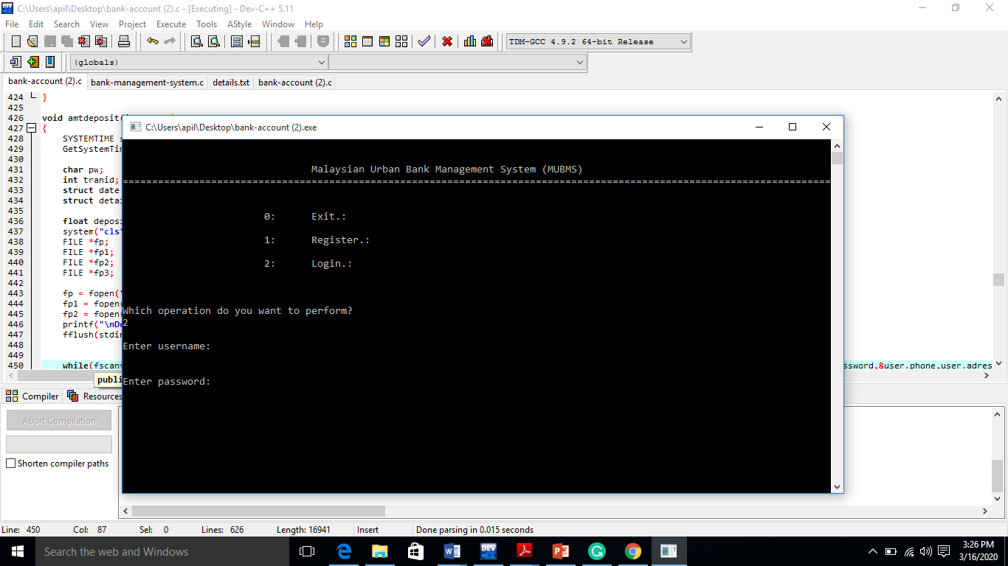

When register account and user want to login. Display enter username: and enter password:

1. Admin menu

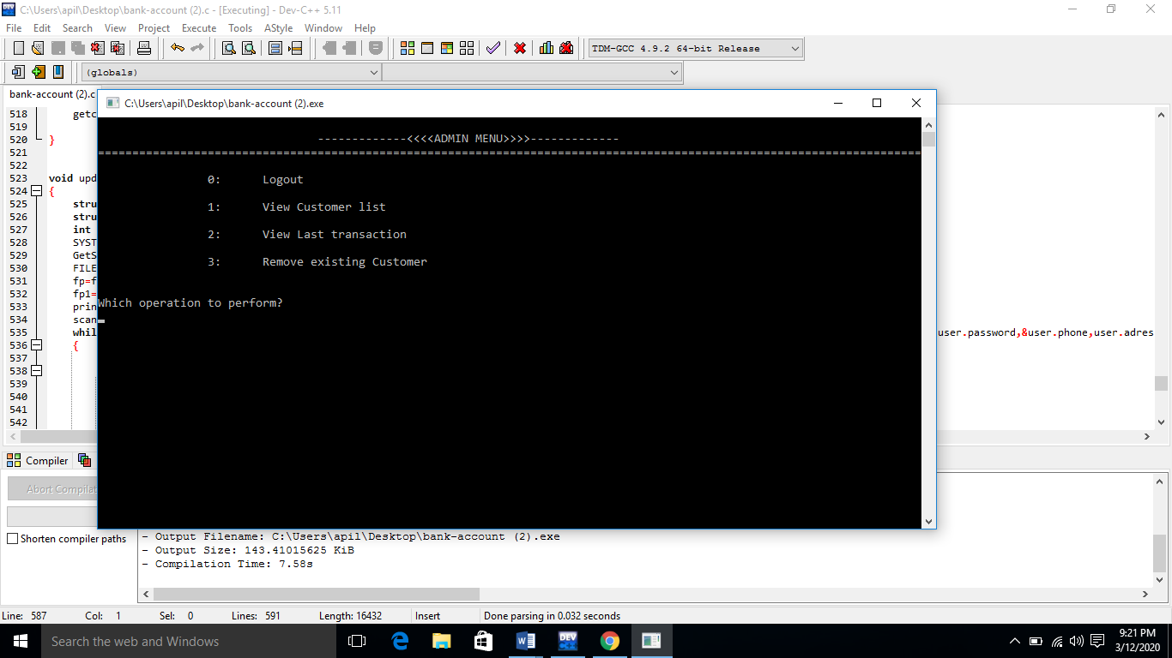

If role will be ‘a’ then login in admin menu. Display this picture page. Choice any option and it worked.

1. Customer menu

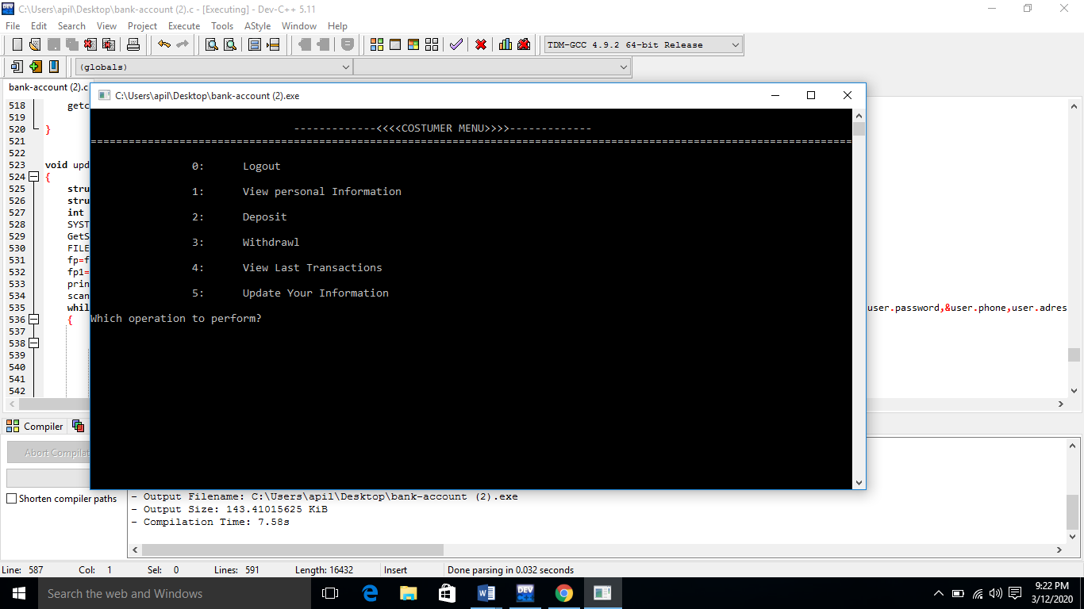

If role will be ‘c’ then login in customer menu. Display 0. Logout, 1. View personal information, 2. Deposit, 3. Withdraw, 4. View last transactions, 5. Update your information. Choice any option and it worked.

1. Deposit:

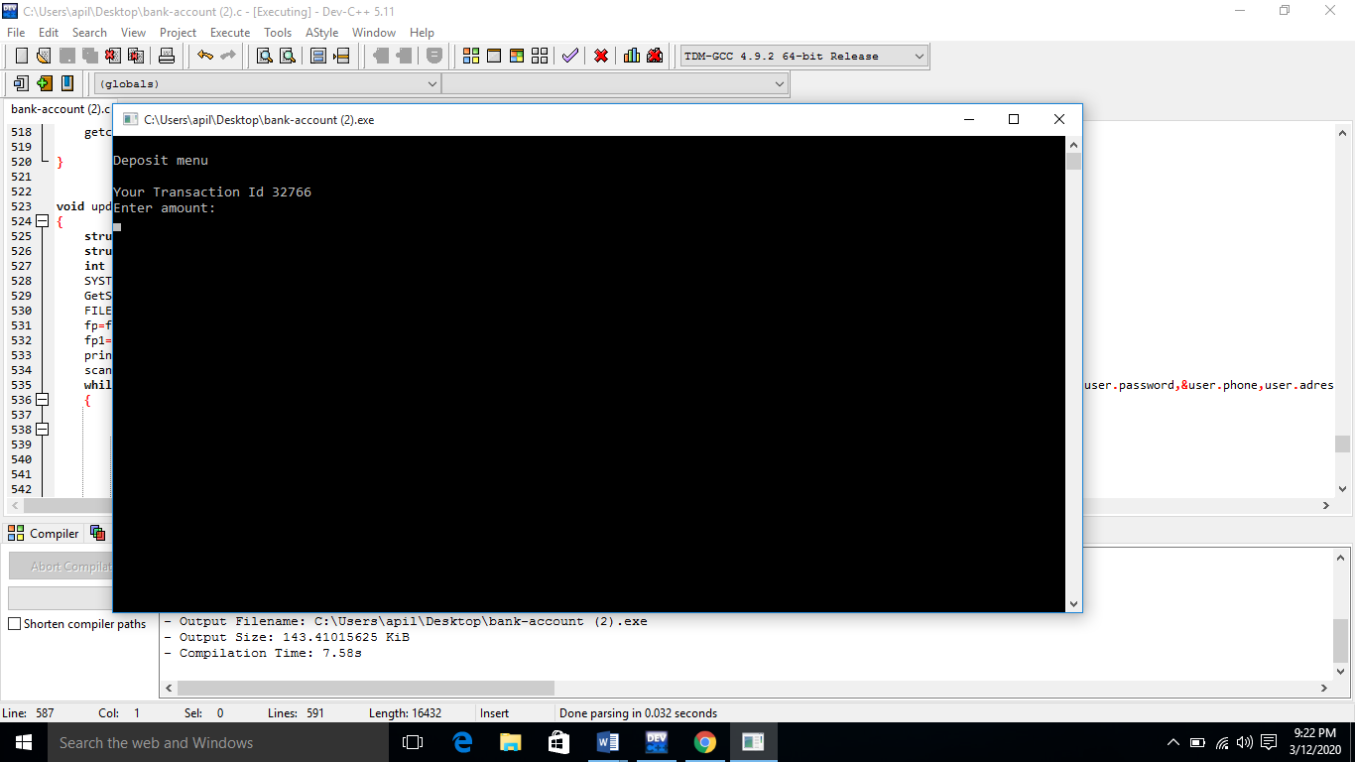

When login in customer menu and choice deposit menu.

1. Withdraw:

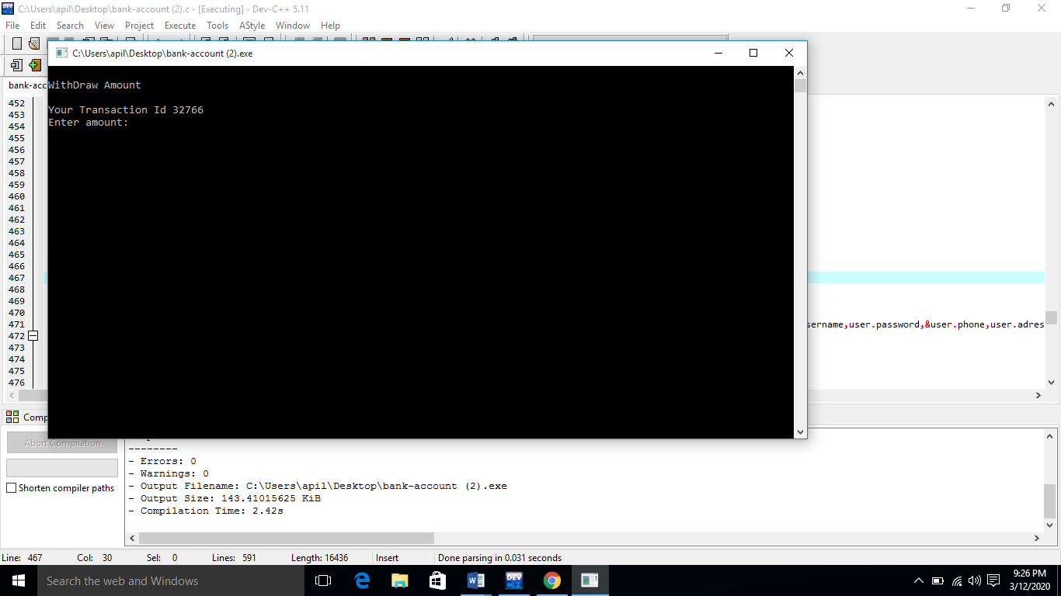

When login in customer menu and choice withdraw menu.